

FPI Mag™

FULL PIPE INSERTION

ELECTROMAGNETIC FLOW METER
MODEL 394L MAG METER SUBMITTAL

From

McCROMETER
3255 WEST STETSON AVENUE
HEMET, CA 92545

Phone (951) 652-6811
Toll Free (800) 220-2279
Fax (951) 652-3078

www.mccrometer.com

Date:

24511-06 Rev. 1.0/03-11

Project Name:
Purchase Order No.:
Date:
Customer Name:
Submitted By:

3255 WEST STETSON AVENUE • HEMET, CALIFORNIA 92545 USA
www.mccrometer.com TEL: 951-652-6811 • 800-220-2279 • FAX: 951-652-3078 Printed In The U.S.A. Lit. 24511-06 Rev.1.0/03-11
Copyright © 2011 McCrometer, Inc. All printed material should not be changed or altered without permission of McCrometer. Any published pricing, technical data, and instructions are subject to change without notice. Contact your McCrometer representative for current pricing, technical data, and instructions.

EQUIPMENT TO BE SUPPLIED BY McCROMETER, INC.

Part Number | Description |  |  | Qty
Model 394L | Bi-directional FPI-Mag™ Meter
 | (1) Electronic Unit, including:
 |  |  | (1) IP67 Enclosure
 |  |  | (1) Three-Button Key Pad
 |  |  | (1) Back-Lit Graphical LCD Display
(2) Programmable Opto-Isolated Outputs
(1) Digital Input for Batch Function Start, etc.
(1) 4-20mA Output for Forward Flow
(1) 90-265VAC @0.25A Input Power
(1) Electromagnetic Averaging Sensor including:
(1) Protective Coating
 |  |  | (20) Feet of Inter-connecting Sensor Cable
 |  |  | (1) Compression Seal
 |  |  | (1) Set of Retaining/Installation Rods
 |  |  | (1) Top Plate
 | (1) Instruction Manual

Built-In Options
 | Additional Sensor Cable
 |  |  | Specified Total Length: Feet
Special | 18 to 45 VAC/DC Input Power @ 1.6A
Special |  | 10 to 35 VDC Input Power @ 1.5A

Accessories
438000401 | 2” Bronze Corporation Stop
43055-2 | 2” Bronze Valve/Stainless Steel Nipple
43055-3 | 3” Bronze Valve/Stainless Steel Nipple (existing installation)
43059-1 | 2” Stainless Steel Valve/Stainless Steel Nipple
43055-4 | 3” Stainless Steel Valve/Stainless Steel Nipple (existing installation)
75031 | Insertion Tool
0624B339001 | Sun Shield
170007101 | Stainless Steel Tag

FPI Mag™ SPECIFICATIONS

- MAGMETER

General
The magmeter shall consist of two components; an electromagnetic averaging sensor and a converter unit. The magmeter shall automatically sense and correct for shifting velocity profiles in the pipe by constantly obtaining an area weighted mean velocity. The sensor shall have reverse flow measurement capability to be shown using three totalizers: positive, negative, and net. The meter shall be equivalent to the Model 394L FPI Mag Full Profile Insertion Electromagnetic Flow Meter as manufactured by McCrometer, Inc. in Hemet, California.

Converter
The flowmeter converter shall be microprocessor based with a keypad for instrument set up and LCD displays for totalized flow, flow rate engineering units and velocity or totalized flow. The converter shall power the flow-sensing element and provide a galvanically isolated 4-20mA output for flow, and a flow proportional output. The output shall be split for forward and reverse flow: 4-12 mA = reverse flow; 12 mA = zero flow; and 12-20 mA = forward flow. It shall be possible, in the test mode; to easily set the converter outputs to any desired value within their range. The 4-20mA scaling, time constants, pipe size, flow proportional output, engineering units and test mode values shall be easily set via the keypad and display. Two separate fully programmable alarm outputs shall be provided to indicate high/low flow rates, empty pipe, fault conditions, reverse flow and over-range conditions. The converter shall periodically perform self-diagnostics and display any resulting error messages. All set up data and totalizer values may be protected by a password.

Sensor
The flow-sensing element shall be of an electromagnetic multi point averaging type design and factory calibrated to traceable standards, such as NIST. Single point insertion or pressure port sensors shall not be acceptable. Installation of the averaging sensor shall be accomplished under flowing conditions through a 2-inch tap via a full port ball valve or corporation stop into the pipe. Profiling or site calibration shall not be required. Measuring electrodes and reference ground electrodes shall be constructed of 316 stainless steel to ensure no corrosion occurs by the passing fluid. Sensor shall have epoxy coating over stainless steel to help from attack of UV, chemical resistance and excess buildup. Sensor shall be suitable for clean, potable, raw (check algae content) or other debris-free water applications. The sensor shall not be damaged by extended operation at partially full or empty pipe conditions.

Sensor Cable
The sensor cable is 20 feet of multi-conductor; abrasive resistant, PVC jacketed cable flexible to -40°F. The sensor cable shall be permanently bonded to the sensor. Additional sensor cable, up to 250 feet shall be available as an option.

Mounting Hardware
Stainless steel retaining rods, of sufficient length, shall be provided for the smooth installation of the electromagnetic averaging sensor. Shorter stainless steel retaining rods shall also be provided for the continuous operation of the electromagnetic averaging sensor. In order to provide stable and secure sensor placement, the sensor shall be capable of compression up to 300 lbs. for use in low pressure PVC pipes and 450 lbs. for use in low pressure metal pipes. For applications other than low pressure, contact factory for compression instructions.

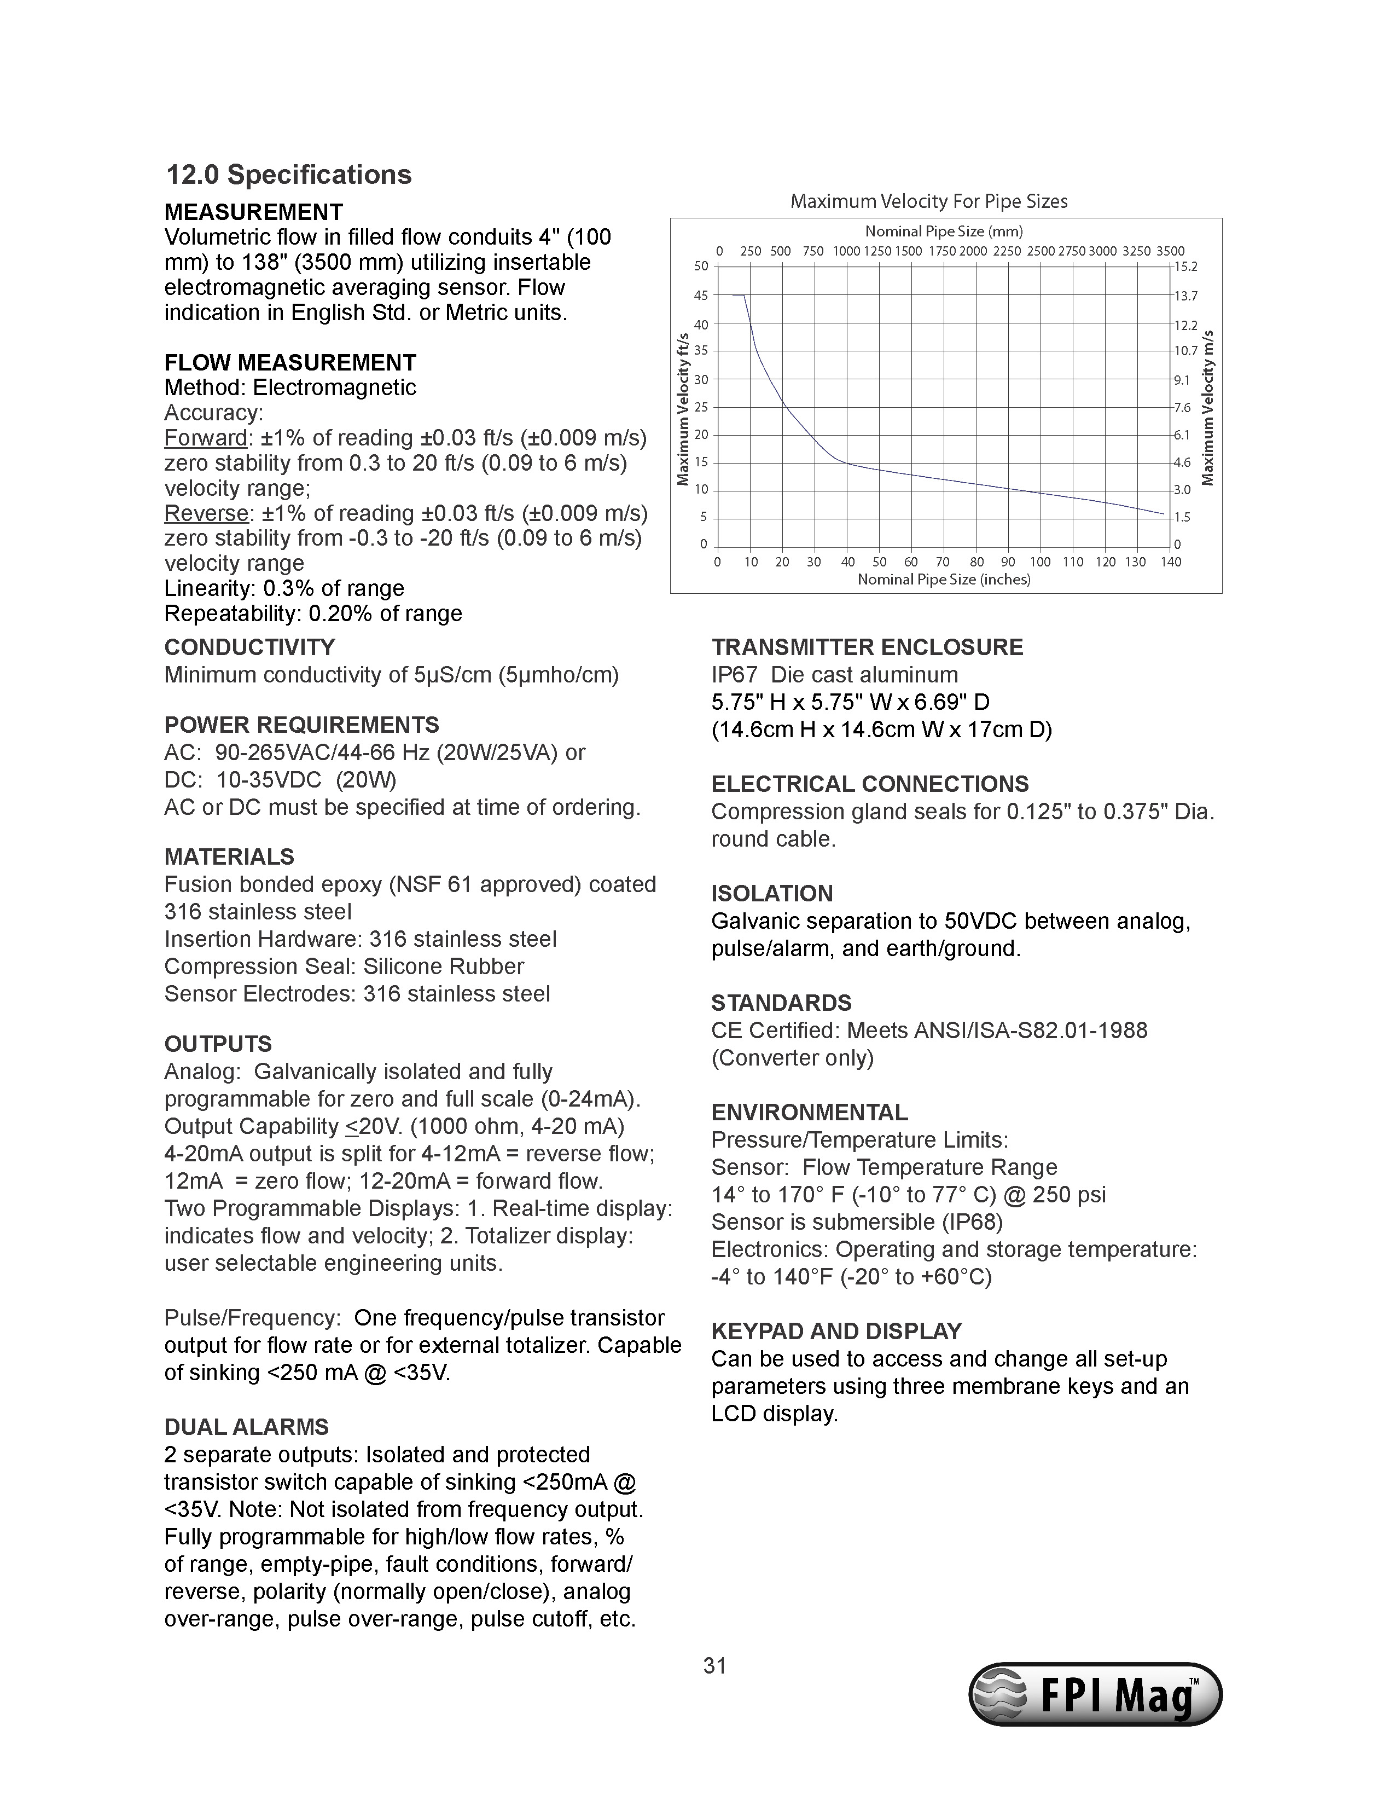

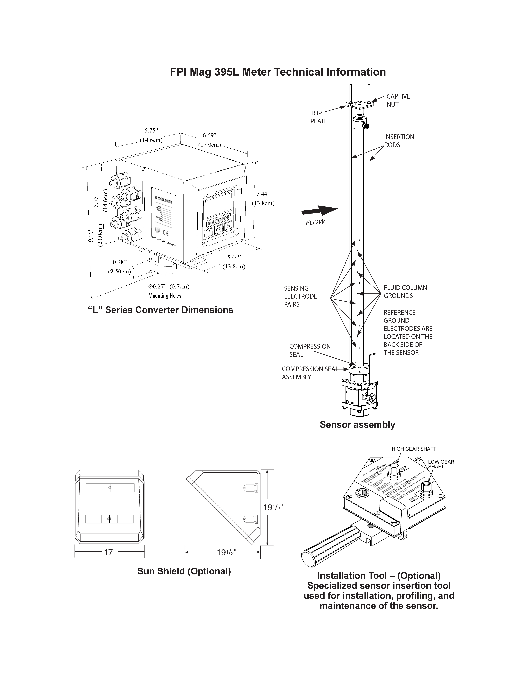
FPI Mag 394L Meter Technical Information
