

SPI Mag™
MODEL 282L SINGLE POINT INSERTION
ELECTROMAGNETIC FLOW METER
1” SENSOR
SUBMITTAL PACKAGE

From

McCROMETER, INC.
3255 WEST STETSON AVENUE
HEMET, CA 92545

Phone (951) 652-6811
Toll Free (800) 220-2279
Fax (951) 652-3078

www.mccrometer.com

Date:

Lit # 24510-93 Rev. 1.2

Project Name:
Purchase Order No.:
Date:
Customer Name:
Submitted By:

3255 WEST STETSON AVENUE • HEMET, CALIFORNIA 92545 USA
www.mccrometer.com TEL: 951-652-6811 • 800-220-2279 • FAX: 951-652-3078 Printed In The U.S.A Lit. #24510-93 Rev.1.2/07-10
Copyright © 2010 McCrometer, Inc. All printed material should not be changed or altered without permission of McCrometer. Any published pricing, technical data, and instructions are subject to change without notice. Contact your McCrometer representative for current pricing, technical data, and instructions.

EQUIPMENT TO BE SUPPLIED BY McCROMETER, INC.

Part Number |  | Description |  |  |  |  | Qty
Model 282L |  | 1” FPI Mag™ Meter , “L” Series
 |  | Specify Pipe ID
 |  | (1) Converter, including:
 |  |  | (1) NEMA 6 Enclosure
 |  |  | (1) Three-button Key Pad
 |  |  | (1) Back-Lit Graphical LCD Display
(1) Programmable Opto-Isolated Output
(1) Digital Input for Batch Function Start, etc.
(1) 4-20mA Output for Flow
(1) 90 to 265VAC @ 0.25A Input Power
 |  | (1) Electromagnetic Full Pipe Sensor including:
 |  |  | (20) Feet of Inter-connecting Sensor Cable
 |  |  | (1) Compression Seal
 |  |  | (1) Choice of one Stainless Steel Insertion Tube with insertion hardware:
12” length Insert Tube Length:
24” length
36” length
 |  | (1) Instruction Manual

Built-In Options
 |  | Additional Sensor Cable:
 |  |  | Specified Total Length: Feet
Special |  | 18 to 45 VAC/DC Input Power @ 1.6A
Special | 10 to 35 VDC Input Power @ 1.5A

Accessories
24511-13 |  | Additional Instruction Manual
24510-58 |  | Additional Sensor Profiling Guide
43801-1 |  | Bronze Valve/Stainless Steel Nipple
43802-1 |  | Stainless Steel Valve/Stainless Steel Nipple
0624B339001 |  | Sun Shield
170007101 |  | Stainless Steel Tag
360000701 |  | IF2 Serial Device

SPI Mag™ SPECIFICATIONS

Model 282L – 1”

General
The flow meter shall consist of two components: an electromagnetic sensor and a converter for clean water only. The flow meter is for use in clean water applications only. The electromagnetic sensor shall be capable of operating in pipe diameters from 2” to 30” inches. The flow meter shall determine the volumetric flow rate by means of the Continuity Equation where flow rate “Q” equals mean velocity “V” times cross sectional area “A” (Q = V x A). The velocity measurement must be taken at a known location, then, through empirically established equations, the sensed velocity will be converted to a mean velocity. The meter shall be equivalent to the SPI Mag Model 282L Single Point Insertion Electromagnetic Flow Meter as manufactured by McCrometer, Inc., in Hemet, California.

Electronics
The flow meter converter shall be microprocessor based with a keypad for instrument setup and LCD displays for totalized flow, flow rate, engineering units and velocity or totalized flow. The converter shall power the flow-sensing element and provide a galvanically isolated 4-20mA output for flow, and one flow proportional or frequency output (transistor type) for flow rate or for external totalizer. It shall be possible, in the test mode, to easily set the transmitter outputs to any desired value within their range. The 4-20mA scaling, time constant, pipe size, flow proportional output, engineering units and test mode values shall be easily set via the keypad and display. Two separate, fully programmable alarm outputs shall be provided to indicate high/low flow rates, empty pipe, fault conditions, reverse flow and over-range conditions. The transmitter shall periodically perform self-diagnostics and display any resulting error messages. All setup data and totalizer values may be protected by a password.

Sensor
The flow-sensing element shall be of an electromagnetic single point type design and factory calibrated to traceable standards, such as NIST. The sensor shall be made of a polyurethane with pure carbon electrodes exposed to flow. Installation of the sensor shall be accomplished under flowing conditions through a 1-inch valve, with final location being located near the inside wall of the flow conduit or 1/8 pipe I.D. To eliminate erroneous readings due to pipe wall effects, the sensor must have its electrodes located at least 3/16” from pipe wall and be designed with a curved tip shape, so as not to collect debris while in the operating position. Flat tipped or Doppler sensors shall not be acceptable.

Sensor Cable
The sensor cable is 20 feet of multi-conductor, abrasive resistant, jacketed cable flexible to -40°F. The sensor cable shall be permanently bonded to the sensor. Additional sensor cable, up to 300 feet, shall be available as an option.

Mounting Hardware
A stainless steel insertion tube and retaining rod shall be provided for the smooth installation and operation of the velocity sensor. The stainless steel insertion tube and rod shall be of sufficient length to allow a full profile of the flow conduit. The stainless steel hardware shall be rated for 250 PSI @ 160°F. Hardware must allow sensor to be secured by bolts when the sensor is being inserted and retracted. A stainless steel compression seal shall also be supplied.

MEASUREMENT
Volumetric flow in filled flow conduits 2” (50mm) to 96” (2440 mm) in diameter utilizing insertable velocity sensor. Flow indication in English std. or Metric units.

FLOW MEASUREMENT
Method: Electromagnetic
Accuracy: ±2% of reading ±0.03 ft/s (±0.009 m/s) zero stability from 0.3 to 20 ft/s (0.09 to 6 m/s) velocity range
Velocity Range: +0.3 to +30 ft/s (+0.09 to +9 m/s)
Has reverse flow indication.

CONDUCTIVITY
Minimum conductivity of 5μS/cm (5μmho/cm)

POWER REQUIREMENTS
AC: 90-265V 44-66 Hz (20W/25VA) or
DC: 10-35V at 20W.
AC or DC must be specified at time of ordering.
MATERIALS
Sensor: Polyurethane exposed to flow
2” Sensor Mounting: PVC and Stainless Steel exposed to flow. (Stainless Steel Insertion Tube Optional)
Compression Seal: Buna “N” exposed to flow.

OUTPUTS
Analog: 4-20mA 1000 Ohms galvanically isolated and fully programmable.
Pulse: 2 Pulse/Frequency/Alarm outputs programmable for high/low flow rates, percent of range, empty pipe, fault conditions, forward/reverse, polarity (normally open/close), analog over-range, pulse over-range, etc.

DUAL ALARMS
2 separate outputs: Isolated and protected transistor switch capable of sinking <250mA @ <35V. Note: Not isolated from frequency output. Fully programmable for high/low flow rates, % of range, empty-pipe, fault conditions, forward/reverse, polarity (normally open/close), analog over-range, pulse over-range, pulse cutoff, etc.

CONVERTER ENCLOSURE
IP67 Die cast aluminum enclosure
5.75” H x 5.75” W x 6.69” D
(14.6 cm H x 14.6 cm W x 17 cm D ). Weight: 6.8 lbs. (3.1 kg)

ELECTRICAL CONNECTIONS
Compression gland seals for 0.125” to 0.375” dia. round cable.

ISOLATION
Galvanic separation to 50VDC between analog, pulse/alarm, and earth/ground.

STANDARDS
CE Certified (Converter only)

ENVIRONMENTAL
Pressure/Temperature Limits:
PVC Insertion Tube:
Up to 105°F (41°C) at 150 psi
Stainless Steel Insertion Tube:
Up to 160°F (71°C) at 250 psi
(McCrometer recommends the use of Stainless Steel)
Electronics: Operating and storage temperature: -4° to 140°F (-20°C to +60°C)

KEYPAD AND DISPLAY
Can be used to access and change all set-up parameters using three membrane keys and LCD display.

OPTIONS
DC Power
Pole mounting kit
Sun shield
Sensor insertion tool
Stainless steel ID tag
Valves
Additional sensor cable up to 300’ (for longer lengths, consult factory)

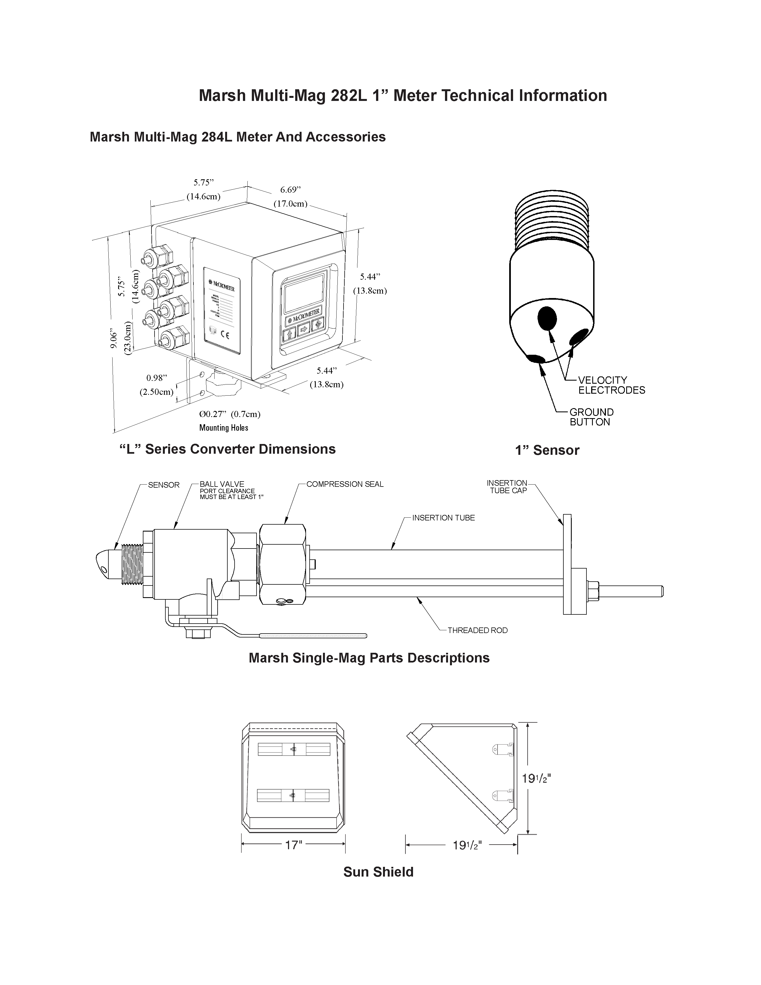
SPI Mag 282L 1” Meter Technical Information

Sun Shield (Optional)
SPI Mag Parts Descriptions

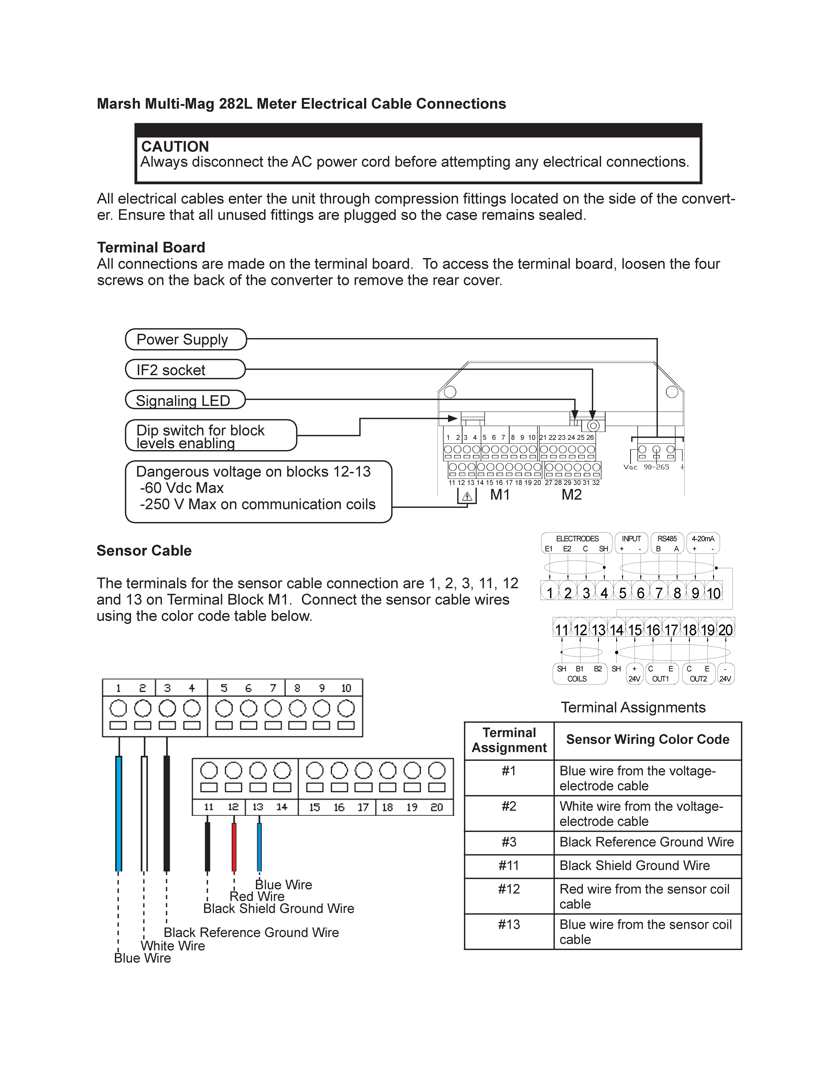
SPI Mag 282L Meter Electrical Cable Connections

